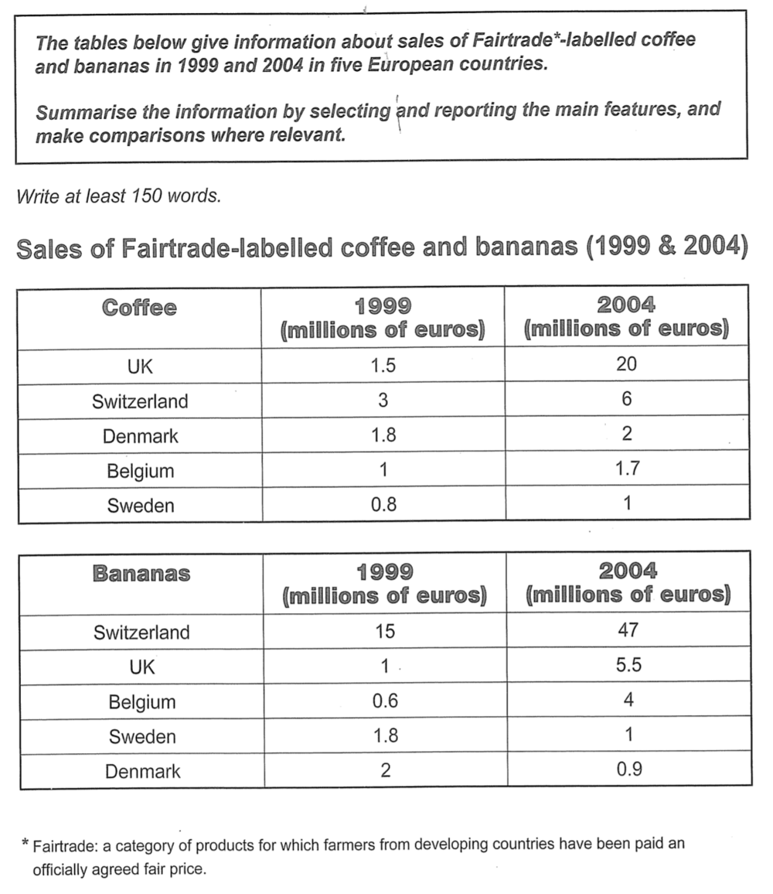

题目分析：这个图是表格，动态图，时间是1999和2004（过去时）
描述对象：the sales of coffee and bananas
单位：million euros
Overview：两个比较维度（趋势和大小）：
①在五个国家，咖啡的销量都上升，但是只有三个国家的香蕉销量上升，Sweden和Denmark是例外。②在销售量大小上，the UK在coffee的销量最大，对应Switzerland在香蕉的销量。

段落结构：两个表格，各写一段。每段比较五个国家的情况。

在咖啡销量上，UK经历最大的增长，要写前后两个数值。Switzerland的两个数值也要写。其余三个国家的数值比较小，可以写一个范围。在香蕉销量上，Switzerland的数值远超其他国家，要写两个数值。 the UK and Belgium的数值也要写。Sweden and Denmark的数值较小，可以简单提到。

在咖啡销量上，比较the UK和Switzerland的大小和增长趋势，然后再和另外三个国家的大小和趋势对比。 在香蕉销量上，比较Switzerland和其他四个国家的数值大小。 对比 Switzerland, the UK and Belgium的趋势。然后和Sweden and Denmark的趋势对比。

The tables illustrate the sales of fair-trade labelled coffee and bananas in five nations in Europe in two years: 1999 and 2004.

Overall, during this period, while the sales of coffee in all five countries increased to varying degrees, in terms of banana sales the same trend was only seen in three countries with Sweden and Denmark being the exceptions. In 2004, the UK dominated coffee sales, compared to Switzerland in bananas sales.

In 1999, the sales of coffee in Switzerland were 3 million euros, twice the figure for the UK. In 2004, although the former doubled, the latter experienced an enormous rise to 20 million euros. In contrast, the sales in the other three countries were much smaller and grew negligibly, ranging from 1 million euros (Sweden, 2004) to 2 million euros (Denmark, 2004).

When it comes to banana sales, Switzerland’s figure was far more than the other countries’, jumping from 15 million euros to 47 million euros. The statistics for the UK and Belgium shared a similar rising trend, climbing from 1 million and 0.6 million to 5.5 million and 4 million respectively. On the other hand, Sweden and Denmark witnessed a decline in banana sales, with their figures approximately halving to about 1 million euros in 2004.

(~211 words)

